# CBHS Analyst Programmer Exam

## Objective:

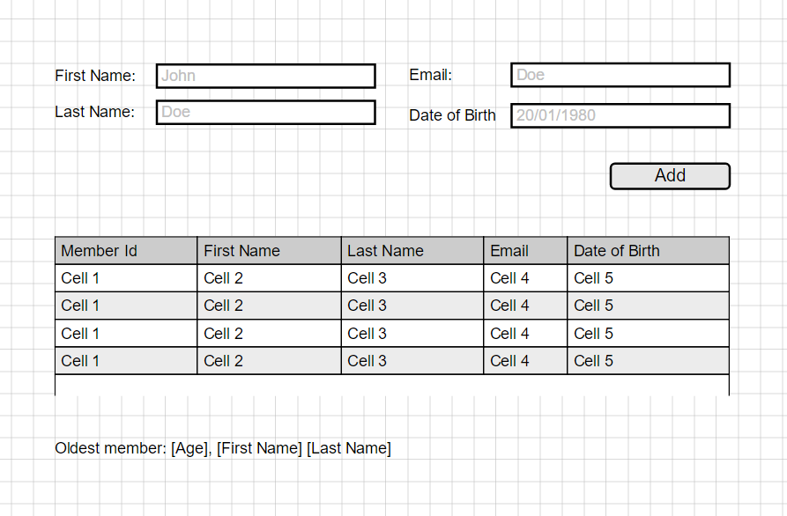

Based on the mock-up above, create an **enterprise-level** web application that:

* 1. Adds a member to a list
  2. Displays added members in tabular view
  3. Display the oldest member’s information

**Do NOT submit without completing ALL requirements.**

## Requirements:

1. Use ASP.NET MVC and RESTFUL WEB API services
2. Demonstrate the use of Dependency Injection across all application layers
3. Must have 100% unit test coverage
4. Use Entity Framework as an ORM
5. Should build and run “out-of-the-box” using VS 2017
6. Demonstrate knowledge on UI Responsive Design
7. Use a mocking framework in Unit Testing.
8. Remove all unnecessary code and references.